E-Learning Program Analysis Report

**Title: "E-Learning Program Analysis "**

**Author: Mr. Sushant Mujagule**

**Purpose: Assignment for Data Analyst Internship**

**Objective:** Simulate and analyze a dataset to derive insights about lead demographics and sourcing efficiency for e-learning programs.

**Analysis:** Here are some graphs and charts are attached from analysis code.

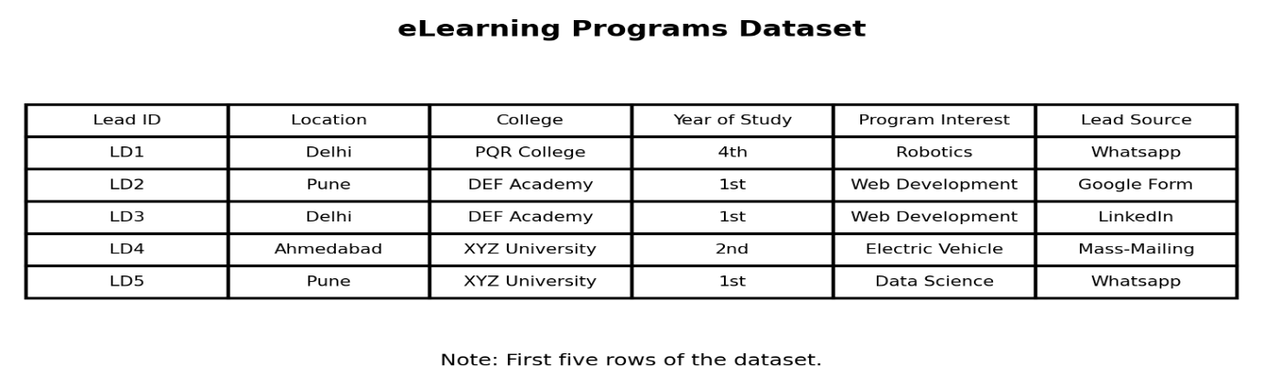

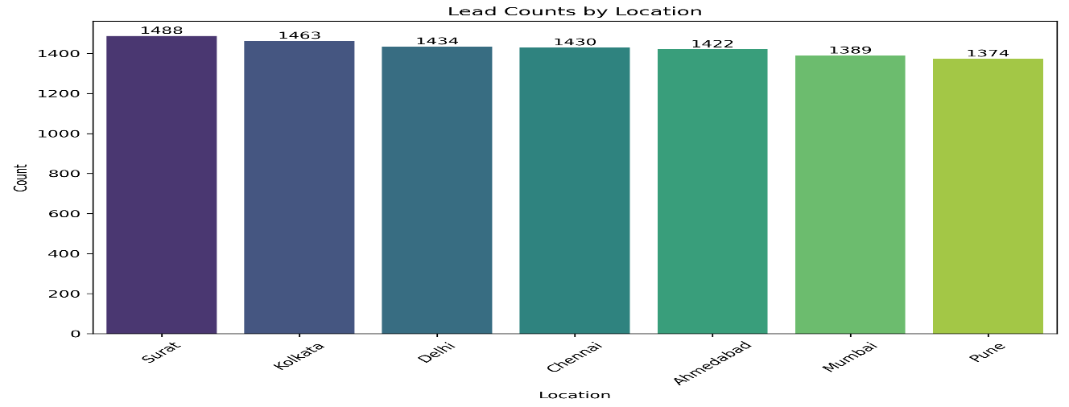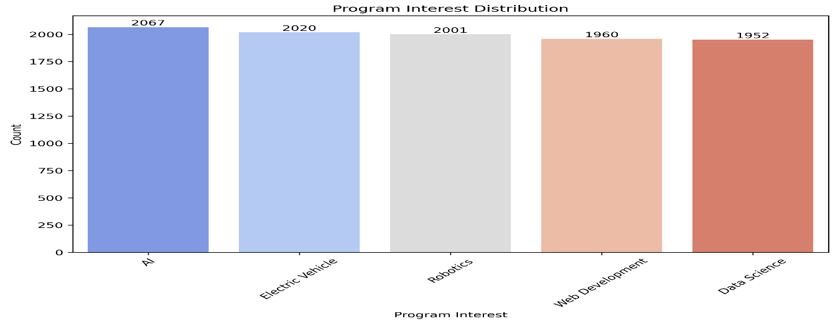

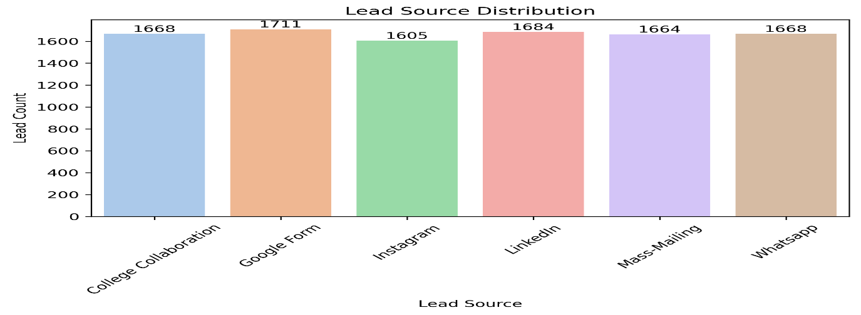

**Findings and Recommendations** –

**Findings:**

1. Surat and Mumbai are the most promising locations for lead generation.
2. Electric Vehicle is the most popular program.
3. Mass-Mailing is the most effective lead source.

**Recommendations:**

1. Focus marketing efforts on Surat and Mumbai.
2. Increase ad spend on Mass-Mailing.
3. Create targeted campaigns for Electric Vehicle.